FAKE CURRENCY DETECTION

***GRASS ROOTS HUB – KENYASI***

**JACOB MENSAH**

**Bright Osei Isaac**

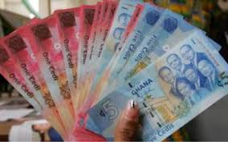

**Introduction**

Object recognitionis an important and highly demanded area of pattern recognition. An object can be anything in real life. It can be text in a document, a license plate of a vehicle, an iris in a person’s eyes, a sign in a sign language, a face of a person, and so on. Similarly, paper currency recognitionis as important as any other object recognition.

This work will sort to deals with a simple but efficient approach in the system design. In designing such a system, it will consider different dimensions, areas, Euler numbers, and correlations as features. This work will be specifically designed to recognize fake paper currency from real currency in the Republic of Ghana. The proposed scheme will be different from various existing methodsbecause of its ability to use the water mark feature in the recognition phases. Using Deep Convolutional Neural Network methods, the summation of non-masked pixel values in each banknote will be computed. The technique in Sargano & Sarfraz (2012)deals with Pakistani paper currency with very different feature set which is specific to regional currency marks and color of the currency. Similarly, the technique introduced inAlthafiri, Sarfraz & Alfarras (2014)is different from the proposed technique as it introduces much greater number of features in their work than Sargano & Sarfraz (2012).

**Problem statement**

The Bank of Ghana (BoG) in 2016 narrated the arrest of several corporates in the attempt to produce counterfeit notes into the market. These activities have led to the loss of several millions of Ghana cedis each and everyday by traders.

**Objective**

The objective of this project is to determine whether the currency is counterfeit one or the original one. The term counterfeit money is imitation of the currency produced without the legal sanction of the state or government. Producing or using this fake money is a form of fraud or forgery.

**Related works**

A system for the recognition of paper currency is one kind of intelligent system which is a very important need of the current automation systems in the modern world of today. It has various potential applications including electronic banking, currency monitoring systems, money exchange machines, etc.

Sarfraz (2015) This paper proposes an automatic paper currency recognition system for paper currency. It uses Radial Basis Function Network for classification. The method uses the case of Saudi Arabian paper currency as a model. The system deals with 110 images and had an overall Average Recognition Rate as 91.51%.

Gunaratna, Kodikara & Premaratne (2008) proposed a system that came up with a solution focusing on minimizing false rejection of notes using three layer back propagation neural network. The experiments showed good classification results and proved that the proposed methodology has the capability of separating classes properly in varying images

Mohammad & Alshayeji(2015) elaborated on a technique for detectin Counterfeit Currency Based on Bit-Plane Slicing Technique. A new approach is discovered in this paper using the bit plane slicing technique to extract the most significant data from counterfeit banknote images with the application of an edge detector algorithm.

**Dataset**

We generated two different data-sets:

*1 Cedi note data-set:*

Initially, there were 3 smart-phone camera images each of a real 1 Cedi not and the photocopy of a 1 Cedi not (to simulate fake notes) which was destroyed immediately after clicking the images. The images were taken by holding the note and its photocopy against light. This is a requirement as we want all the security features in a real currency note exposed, which involve features like the watermark of Tetteh Quashie and the Cocoa pod and the see-through register. In every image, the currency note covered approximately the entire frame of the image. This provided us with a total of 8 initial images in the data-set.

*5 Cedi note data-set:*

To start with, there will be 4 smart-phone camera images of 4 real 5 Cedi note. Again, the images were taken by holding the note against light. To simulate a fake 5 Cedis note images, we manually erased the exposed watermark through a basic photo editing software.

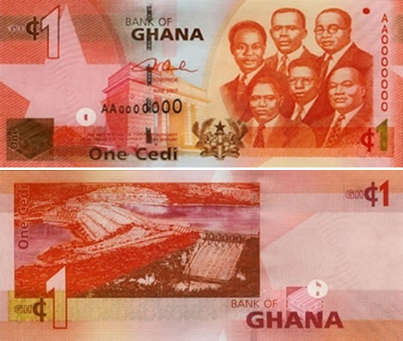

(a) Real 1 Cedi note (Front view) (b) Real 1 Cedi note (Back view)

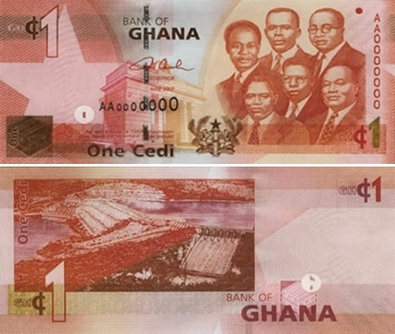



(c) Fake 1 Cedi note (Front view) (d) Fake 1 Cedi note (Back view)

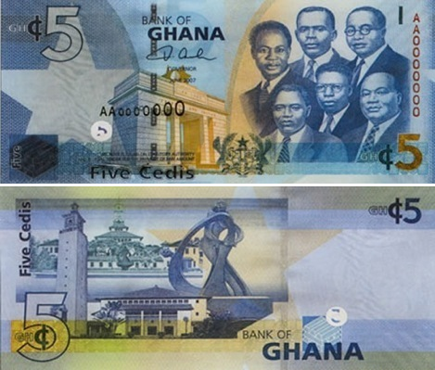

(a) Real 5 Cedi note (Front view) (b) Real 5 Cedi note (Back view)

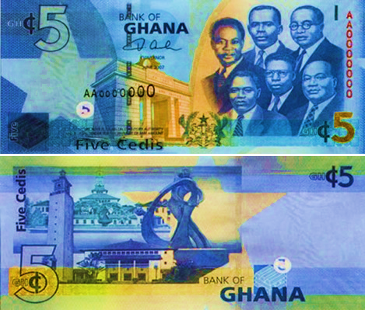  
(c) Fake 1 Cedi note (front view) (b) Real 5 Cedi note (Back view)

*Initial images for generating the data-sets.*

**Method**

We required at least 1000 images in each data-set even for the purpose of fine-tuning a pre-trained DCNN. The simplest way to get around a lack of data is to augment the data-set.

The DCNN is a network with a certain level of complexity, a neural network with more than two layer. DCNN uses sophistication mathematics to process data in a complex way.

The principle behind data augmentation is that from already qualified data, we can generate more by modifying our base. The main benefit of data augmentation is that we get more data, and our training and testing set will gets better. The second one is that since we are adding notes, we get closer to real data, and can improve the measurement of a real-world behaviour of our machine learning technique. For data augmentation purposes, we made use of the OpenCV library. The very first step is to resize the image to a pre-defined size.

The VGG-16 model that we use in our experiments (see next section) requires an input image shape of 224 x 224 x 3, where 3 refers to the R,G,B components of a coloured image and the image must be 224 x 224 pixels in size. We then apply the following three types of transformations for each original image in both the data-sets to augment them.

1. *Image Translation:*

Translated each image with a stride of 5 pixels along both axis along all 4 directions. The range for translation was -30 pixels to +30 pixels. The original image moves within the frame and black pixels to fill the void created thereby.

1. *Image Rotation:*

Rotated each image in the angle range of -10 to +10 degrees with a step equal to 0.5 degree. The axis for rotation passes through the centre of the image and black pixels to fill the void created by rotation.

1. *Perspective Transformations:*

Applied perspective transformations on each image to zoom in the range of 100-130% and zoom out in the range of 100-70%. This added a total of 60 images for each original image in the data-set. The data augmentation process generated 270 images for each original image, resulting in a total of 1620 images for the 1Cedi note data-set and 7020 images for the 5 Cedi note data-set.

**Experiment and result**

For our experiments, we will use the python libraries such as Lasagne and Theano for implementing and training the deep learning model. There are many pre-trained models available on the internet like the GoogleNet, ResNet, InceptionV3, VGG, etc. The VGG networks secured first and the second places in the localization and classification tracks respectively in the ImageNet Challenge 2014. We chose the VGG model for our experiments because it has a very simple structure (see Fig. 2) compared to the other top performing DCNN models.

This makes it easier to interpret. Out of the two best-performing VGG models publicly available to facilitate research, we will use the VGG-16 model, the other being the VGG-19 model. VGG-16 is marked by green rectangle. It is called VGG-16 because it consists of 16 layers with learnable parameters, i.e. weights and biases. The pooling layers does not count as they do not learn anything. To reduce the number of parameters in such very deep networks, small 3x3 filters will be used in all convolutional layers with the convolution stride set to 1. At the end of the network will be three fully-connected layers. The VGG networks use multiple 3x3 convolutional layers to represent complex features.



*Fig 2*

*Training the DCNN*

The model described above was trained using the two datasets separately. Each of the data-sets was randomly divided into training and test sets. The ratio for this division was 2:1. The model was trained for 5 epochs on the 1 Cedi note data-set and for 10 epochs on the 5 Cedi note data-set.

*Results*

The accuracy of the VGG-16 model fine-tuned with the 1 Cedi note training set will be estimated at 86.2% on the corresponding test set. Despite the good score, the result might be attributed to over fitting on the data-set, as the training and test sets were very similar. This result is still very encouraging because an availability of a larger, real-world data-set can make the model more accurately trained and generalize better at the same time. The accuracy of the VGG-16 model fine-tuned with the 5 Cedi note data-set will be estimated at 86.2% on the corresponding test set. This result is not encouraging but can be attributed to the fact that the 5 Cedi note data-set had images which only covered around 60% of the central area of the image and shrink further to 224 x 224 pixels as per the VGG-16 architecture requirement. The task of applying image processing techniques to first detect the edges of a currency note in an image and passing the cropped image to the model can be taken up in future.

**Conclusion and future works**

Future avenues of research include examining various deep neural network architectures which are more efficient in terms of time and space complexity. Applying image pre-processing techniques like noise removal and edge-detection to crop the currency note out of an image will present a better input to the deep neural network.

**Conclusion**

In this work, we demonstrated the feasibility of deploying deep learning techniques for the task of identifying fake currency notes, using the VGG-16 deep convolutional neural network model. We noted how deep convolutional neural networks can work as feature extractors and thus no image processing techniques need to be applied to manually find the presence of security features in a note. Although the generated data-set did not represent the real-world scenario of fake currency notes, it was helpful for experiments. Under the availability of a real data-set, the deep neural networks can be better trained. Such a model may then be built into a smart-phone app and can thus help people in detecting fake notes in case of suspicion in real time with just an image taken through the smart-phones camera. In the form of a smart-phone app, the VGG-16 model has been reported to take up to 550 MB of device memory. In a phone with a with a high-end processor, initialization of the app takes anywhere between 2 to 10 seconds and classification time is around 0.25 to 0.3 seconds per image.

References

Sargano AB, Sarfraz M, Haq N. An Intelligent System for Paper Currency Recognition with Robust Features, *Journal of Intelligent and Fuzzy Systems* 2014; **27(4)**: 1905 –1913.

Althafiri E, Sarfraz M, Alfarras M. Bahraini Paper Currency Recognition, *Journal of Advanced Computer Science and Technology Research* 2012;**2(2)**:104 –115.

Mohammad H Alshayeji, Mohammad Al-Rousan and Dunya T. Hassoun, (2015). Detection Method for Counterfeit Currency Based on Bit-Plane Slicing Technique ,*International Journal of Multimedia and Ubiquitous Engineering* Vol.10, No.11.

*Jiang Wang et al., ”Learning fine-grained image similarity with deep ranking”, Proceedings of the IEEE Conference on Computer Vision and Pattern Recognition, 2014.*

*Kunze, Ike Sebastian,”Fine-Grained Image Classification with Convolutional Neural Networks”, Hauptseminar im Wintersemester 2014/15 Medizinische Bildverarbeitung, p.55.*

*Z. Ge, C. McCool, C. Sanderson, and P.I. Corke., ”Modelling local deep convolutional neural network features to improve fine-grained image classification”, IEEE International Conference on Image Processing, 2015.*